## 1. Pandas Cleaning & Imputation

### 1.1 Merging the Data

1. We’ve four different files comprising the data to be analysed
2. So, to collect all data into single file, we’ve merged the all four files into single dataframe based on “CustomerId” & “RowNumber”

### 1.2 Cleaning the Data & Filling out Missing Values

1. We have removed the duplicates & cleaned the data
2. We’ve used Imputation method as Forward filling by taking neighbour values
3. For the Balance column we have replaced missing values with mean values.

### 1.3 Check the Null Values and Create a Final CSV file.

1. Generated the final csv file without any missing values and cleaned.

## 2. Data Visualization: EDA

### 2.1 Created Correlation map to check how the columns relate to each other

### 

### 2.2 CountPlot to analyse the Excited People based on Gender wise and category wise

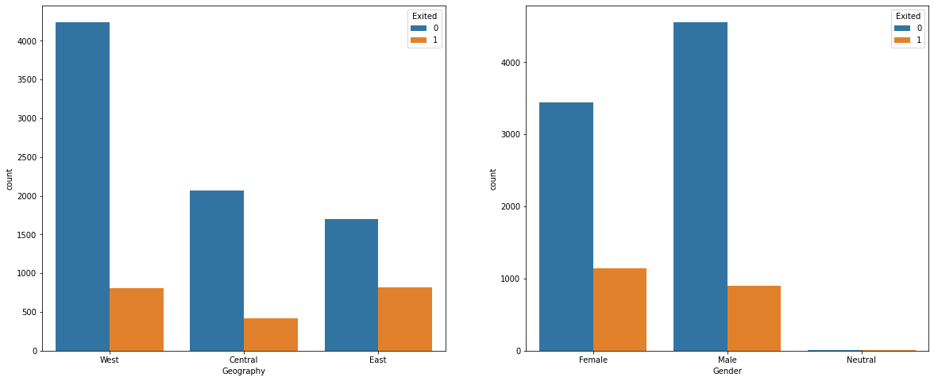

### 2.3 Boxplot to visualize the Age based on Geography & Gender.

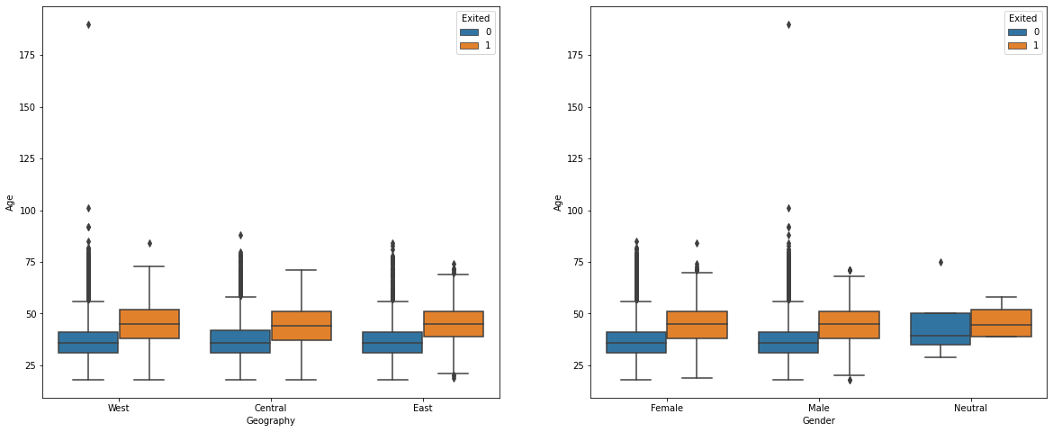

Thanks,

Narendra.